PIZZA SALES SQL QUERIES
A.KPI’s
1.Total Revenue
select sum(total_price) as Total_Revenue from pizza_sales;
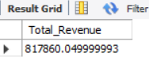
2.Avg Order value
select sum(total_price)/count(distinct order_id) as avg_order_value from pizza_sales;
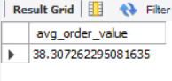
3.Total Pizza Sold
select sum(quantity) as Total_pizza_sold from pizza_sales;
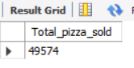
4.Total Orders
select count(distinct order_id) as total_orders from pizza_sales;
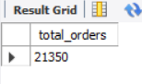
5.Avg Pizzas per Order
select sum(quantity)/count(distinct order_id) as Avg_pizzas_per_order from pizza_sales;
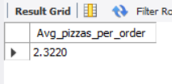
B. Required Charts
Daily Trend:
select dayname(OrderDate) as order_day, count(distinct order_id) as Total_orders
from pizza_sales
group by order_day;
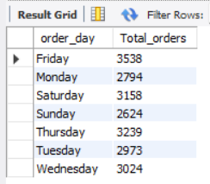

Hourly Trend:
select Hour(OrderTime) as order_Time, count(distinct order_id) as Total_orders
from pizza_sales
group by Hour(OrderTime)
order by Hour(OrderTime);
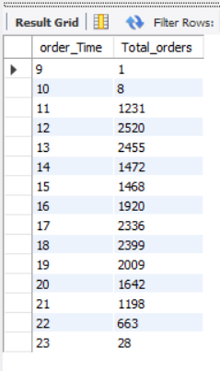

Percentage of Sales by Pizza Category :
select pizza_category, round(sum(total_price)*100/(select sum(total_price) from pizza_sales),2) as percentage_by_category
from pizza_sales
group by pizza_category;
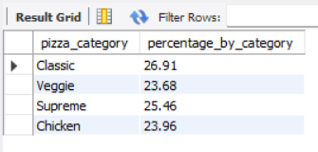
Percentage of Sales by Pizza Size :
select pizza_size, round(sum(total_price)*100/(select sum(total_price) from pizza_sales),2) as percentage_by_size
from pizza_sales
group by pizza_size
order by percentage_by_size desc;
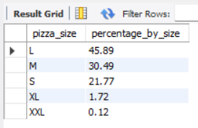
Total pizza sold by Pizza category :
select pizza_category, sum(quantity) as Pizza_sold_by_category
from pizza_sales
group by pizza_category;
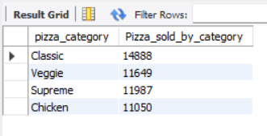

Top 5 Best Seller :
select pizza_name,sum(quantity) as Total_pizza_sold
from pizza_sales
group by pizza_name
order by Total_pizza_sold desc
limit 5;
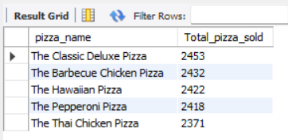
Bottom 5 Seller :
select pizza_name,sum(quantity) as Total_pizza_sold
from pizza_sales
group by pizza_name
order by Total_pizza_sold asc
limit 5;
